**CS5803 DATA VISUALISATION COURSEWORK**

**DATA VISUALISATION COURSEWORK**

# **Introduction**

The global financial world has changed enormously this century, and even more so over the past year, as digital transformation has brought retail investors into the equation. And tech stocks especially have shown extraordinary price volatility and growth patterns, which requires tools that can grasp multi-dimensional trends. In this analysis, historical stock market data for leading technology companies is processed using data visualization.

The project is an initiative to empower financial analysts and retail investors with Tableau-based dashboard to visualize price trends, the trading volume behaviour and the volatility vs. price sentiment and some of the technical momentum indicators such as Moving Averages (MA) crossovers. We map each visualization to a concrete analytical question for capturing in-depth insights from complex time-series and quantitative variables.

# **Dataset**

**Source:** combined_stock_data.csv  
 **Records:** 37,954  
 **Companies Covered:** Amazon, Apple, Meta (Facebook), Google, Microsoft, Nvidia, Tesla  
 **Time Frame:** 1997 – 2020

# **Data Dictionary**

|  |  |  |
| --- | --- | --- |
| **Variable Name** | **Description** | **Type** |
| Date | Daily stock trading date | Date |
| Company | Company name | Categorical |
| Close | Closing price of stock | Continuous (USD) |
| Volume | Number of shares traded | Continuous |
| percentage change in price | Day-over-day percentage price change | Continuous (%) |
| percent change in volume | Day-over-day volume fluctuation | Continuous (%) |
| MA50 | 50-day moving average | Continuous |
| MA200 | 200-day moving average | Continuous |

# **Persona**

**Name:** Priya Nair  
 **Age:** 28  
 **Profession:** Investment Research Analyst at a Fintech Startup  
 **Goal:** Use dynamic visual tools to identify investment timing opportunities, detect market momentum, and evaluate historical stock sentiment for decision-support.

.

# **Research Questions**

#### ***Q1) How have the closing prices of different companies changed over time?***

*Relationship: Time Series*

* **Visualization:** Line/Area Chart (Date vs Closing Price)
* **Interaction:** Filter by company and date
* **Insight:** Identify growth periods and overall company trajectory

#### ***Q2) How does average trading volume vary across companies?***

*Relationship: Nominal Comparison*

* **Visualization:** Stacked Bar Chart (Company vs Volume)
* **Interaction:** Filter by year range
* **Insight:** Pinpoints high-activity periods, likely linked to events

#### ***Q3) What is the relationship between price change and volume change?***

*Relationship: Correlation*

* **Visualization:** Scatterplot (% Price Change vs % Volume Change)
* **Interaction:** Tooltip, company filter
* **Insight:** Reveals how trading sentiment drives price

#### ***Q4) Do MA50 and MA200 crossovers reliably signal momentum shifts?***

*Relationship: Coordinated View / Interaction Required*

* **Visualization:** Dual Line Chart (MA50 vs MA200)
* **Interaction:** Filter by company and date; color-coded crossover detection
* **Insight:** Provides timing cues for bullish/bearish transitions

# **Requirements**

### **R1. To address Q1, the user must visualize stock closing price trends over time to analyze growth patterns, volatility, and identify optimal investment periods.**

* **Chart Type:** Area Line Chart
* **X-axis:** Date (converted to month/year)
* **Y-axis:** Closing Price (USD)
* **Plot Type:** Continuous multi-line chart by company
* **Filter:** Company and Year
* **Insight:** Reveals company-wise performance trends and market phases (e.g., crashes, booms, rebounds)

*Static chart with clearly separated colored lines per company over the years. Tooltip shows exact closing price per date.*

**Variables used:**  
 Dimensions – Date, Company  
 Measures – Close (Price)

### **R2. To address Q2, the user compares average trading volumes across companies to detect high-activity stocks and institutional interest.**

* **Chart Type:** Grouped Bar Chart (vertical or stacked)
* **X-axis:** Company
* **Y-axis:** Average Trading Volume
* **Interaction:** Filter by year or date range
* **Color:** By Company
* **Insight:** Highlights which stocks saw unusual volume spikes, indicating major events or investor moves

*Tooltips display exact average volume. Optionally enable user to compare across months or market cycles.*

**Variables used:**  
 Dimensions – Company  
 Measures – Volume (Average), Date (optional for filtering)

### **R3. To address Q3, the user investigates the correlation between percentage change in price and volume to evaluate how investor sentiment reacts to market movements.**

* **Chart Type:** Scatter Plot
* **X-axis:** Percentage Change in Price
* **Y-axis:** Percentage Change in Volume
* **Color:** By Company
* **Filter:** Company, Year
* **Insight:** Clustering near origin suggests low-volatility stocks; outliers signal speculation, news reactions

*Interactive chart with hover-enabled tooltips showing price and volume swings for specific companies.*

**Variables used:**  
 Dimensions – Company  
 Measures – percentage change in price, percent change in volume

### **R4. To address Q4, the user tracks technical momentum via MA50 and MA200 crossovers and uses forecasting to anticipate potential future trends, helping detect bullish or bearish transitions in advance.**

* **Chart Type:** Dual Line Chart
* **X-axis:** Date
* **Y-axis:** Moving Averages (MA50 & MA200)
* **Interaction:** Filter by Company, Date Range, and Forecast Toggle (ON/OFF)
* **Color Scheme:** MA50 (blue), MA200 (orange), optionally highlight crossover points
* **Insight:** Bullish crossover = MA50 rises above MA200; Bearish crossover = MA50 drops below MA200. Forecasting overlays projected MA trends to help with forward-looking strategy.

*User can enable forecasting (e.g., next 30–60 days) via a toggle. Projected trend lines will appear with a dotted style and shaded confidence bands.*

**Variables used:**  
 Dimensions – Date, Company  
 Measures – MA50, MA200  
 Calculated Fields – Forecasted MA50, Forecasted MA200 (optional model-based smoothing or time-series projection)

# Design

Below is the annotated paper landscape sketch illustrating insights from Stock data.

**Gap Between Paper Landscape Sketch and Implementations (Tableau)**

As the first prototype of a paper landscape showing a typical view on our overarching research questions from the stock domain, such a sketch provided an initial layout for each research question related to stocks, but only illustrated a coarse-grained static view over the records. The visual was made more attractive and informative with Tableau as interactive, dynamic and multi-dimensional visuals added to the quality of this dashboard.

The initial sketch — an area line graph for closing prices of companies — becomes a static chart in the sketch, but can be a dynamic area line chart in Tableau with interactivity like company filters, tooltips with hover, and better viewability with color segmentation. This provided users with the ability to immediately visualize growth trends over a 25-year period.

In summary, while the paper sketch outlined layout and charting intention, the Tableau dashboard added in interactive capabilities and statistical improvement (predictive), color design and dynamic filtering. This shift allowed for more than insights to be visualized — they could be explored — enabling the end user to dive deeper into their analysis and make faster decisions.

# **Implementation**

### **Step 1: Connect to the Dataset**

* Open Tableau and connect to the CSV file: combined_stock_data.csv.
* Ensure the Date column is recognized as a **Date** data type.
* Rename worksheet to Stock Data View.
* Verify fields: Company, Close, Volume, percentage change in price, percent change in volume, MA50, MA200 are loaded correctly.

### **Step 2: View for Research Q1 – Closing Price Trend Over Time**

**Goal:** Identify how stock prices for each company evolved over time.

* Drag Date to **Columns** → convert to **Month (continuous)**.
* Drag Close to **Rows** → set aggregation to **AVG(Close)**.
* Drag Company to **Color**.
* Set **Marks type** to Area or Line.
* Format the **Y-axis** to display currency in USD.
* Add **Year filter** (optional): Drag Date to Filters, select specific years (e.g., 2015–2023).
* Title: **"Q1 – Monthly Closing Price Trends by Company"**

### **Step 3: View for Research Q2 – Average Trading Volume by Company**

**Goal:** Compare how active each company is in trading volume over time.

* Drag Company to **Columns**.
* Drag Volume to **Rows** → set aggregation to **AVG(Volume)**.
* Set **Marks type** to Bar.
* Drag Year(Date) to **Filters** (optional) and set it as a filter control.
* Add Volume to **Label** for exact figures.
* Title: **"Q2 – Average Trading Volume by Company"**

### **Step 4: View for Research Q3 – Price vs. Volume Change (Sentiment Indicator)**

**Goal:** Explore the correlation between price and volume fluctuations.

* Drag percentage change in price to **Columns**.
* Drag percent change in volume to **Rows**.
* Drag Company to **Color**.
* Set **Marks type** to Circle.
* Add Date and Close to Tooltip for better data context.
* Add filters for Company and Date Range.
* Title: **"Q3 – % Price Change vs. % Volume Change (Investor Sentiment)"**

### **Step 5: View for Research Q4 – MA50 vs. MA200 with Forecasting Option**

**Goal:** Detect technical momentum signals using MA crossover logic and project future movements.

* Drag Date to **Columns** → convert to **Month (continuous)**.
* Drag MA50 and MA200 to **Rows**.
* Drag Company to **Filter** and **Detail**.
* Use **dual-axis** to overlay both MA lines.
* Set **Marks type** to Line → assign MA50 (blue), MA200 (orange).
* From the **Analytics pane**, drag Forecast to MA50 line → set:
  + Forecast Length: 3 months
  + Model: Custom
  + Trend: Additive
  + Seasonality: Multiplicative
* Drag Forecast Indicator to **Color** to distinguish actual vs. projected MA50.

### **Step 6: Create the Interactive Dashboard**

1. Go to **Dashboard > New Dashboard** → name it: Stock Intelligence Dashboard.
2. Set fixed size: **1080 × 1920 px**.
3. Add the 4 worksheets:
   1. Q1 – Price Trends
   2. Q2 – Volume Comparison
   3. Q3 – Sentiment Scatterplot
   4. Q4 – MA Crossovers
4. Apply **dashboard filters** for:
   1. Company
   2. Year(Date)
   3. Forecast Indicator
5. Customize:
   1. Add headers above each chart
   2. Use floating containers for tooltips and dropdowns
   3. Set chart colors for consistency across views

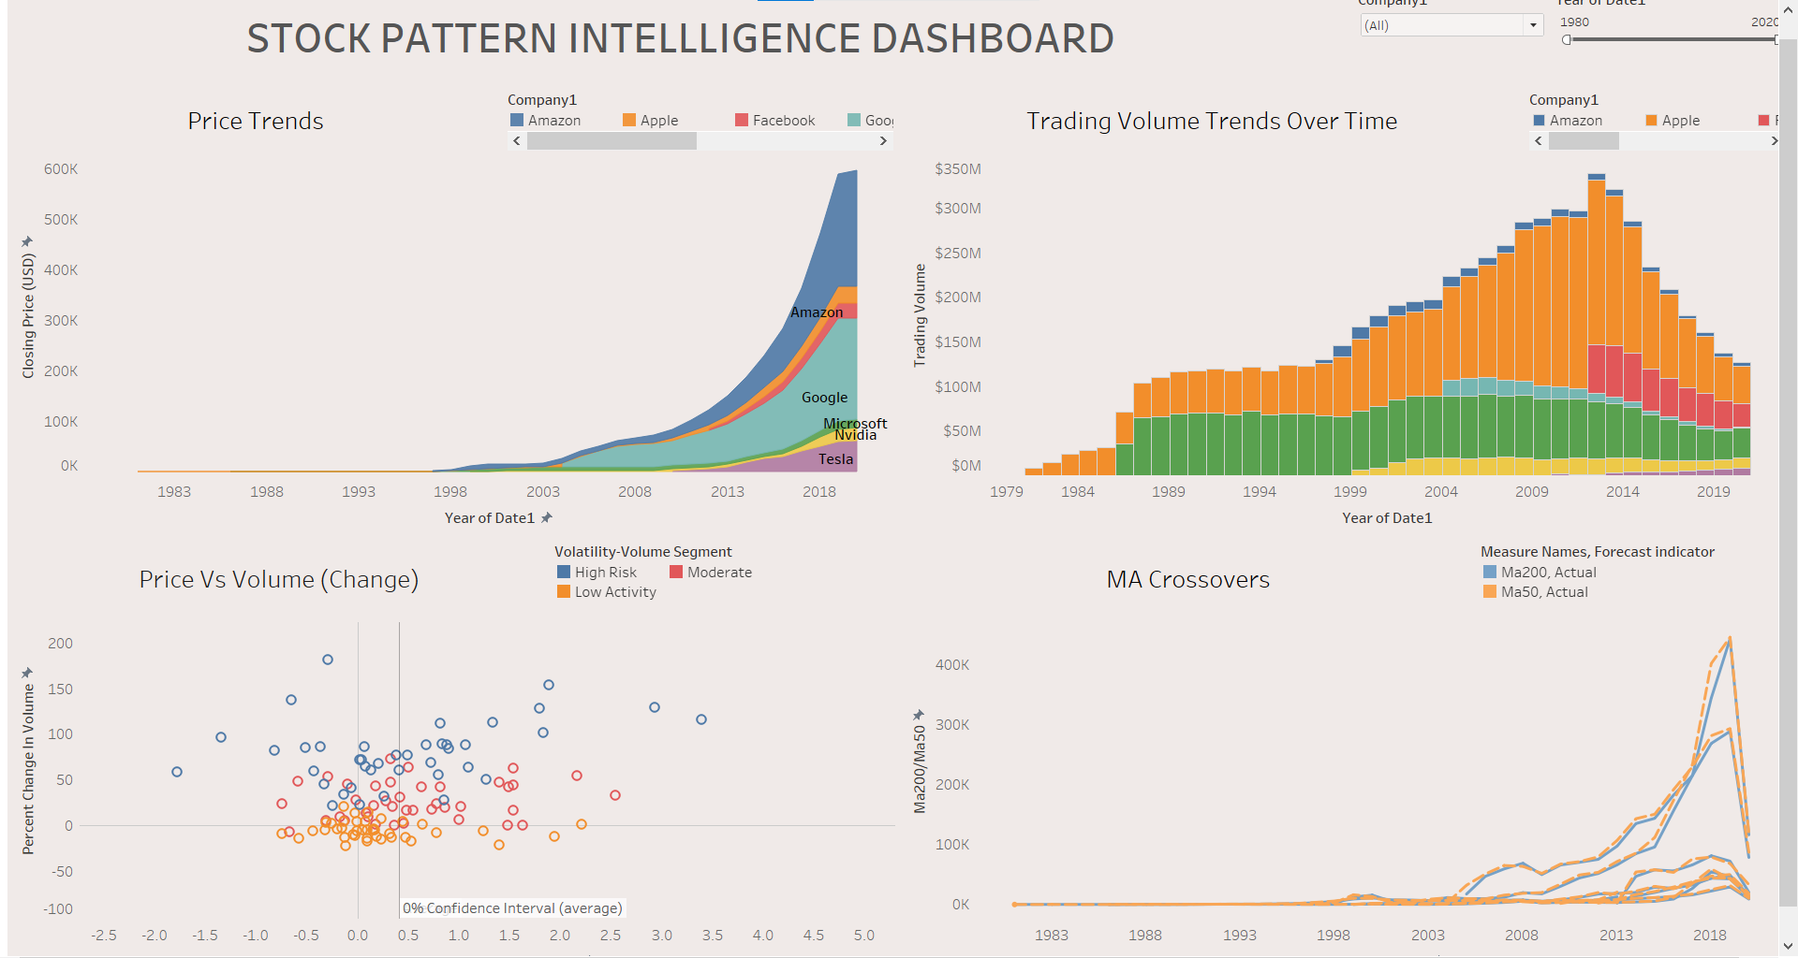

# **Walkthrough**

Following is the illustration of how the views answer the Research Questions:

## Q1(Story1)

## The area line chart presents the month-wise average **closing prices** of seven tech companies between 1997 and 2023. Users can **filter by company** to isolate individual growth trends or compare multiple firms simultaneously.

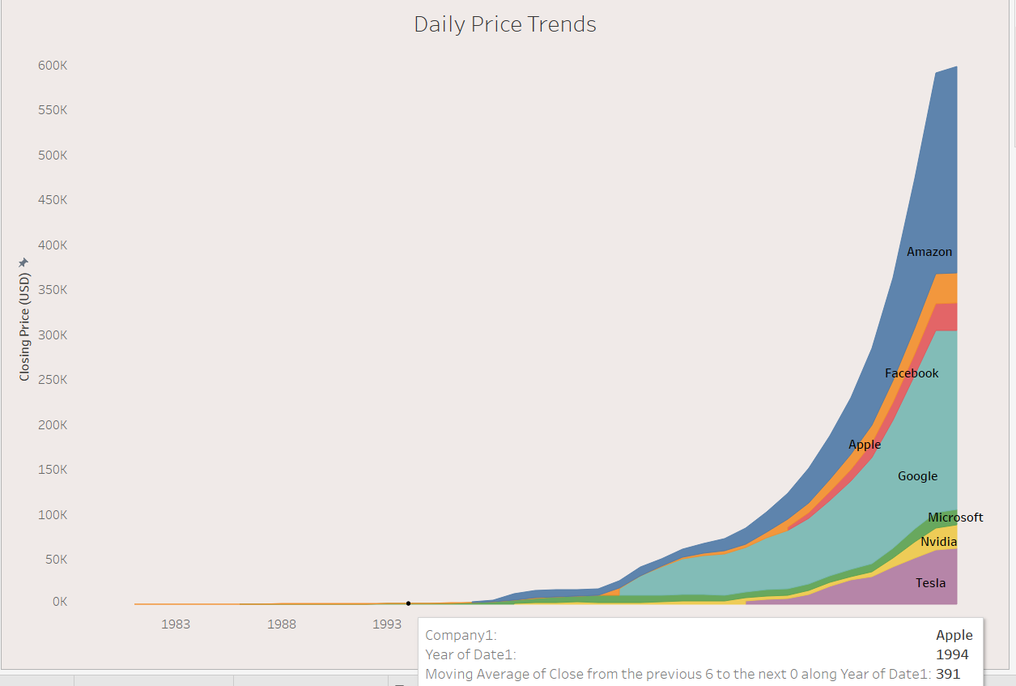

## Q2(Story2)

This vertical **stacked bar chart** displays the **average trading volume** per company across the dataset’s timeline. Volume acts as a **proxy for investor interest**, particularly institutional involvement

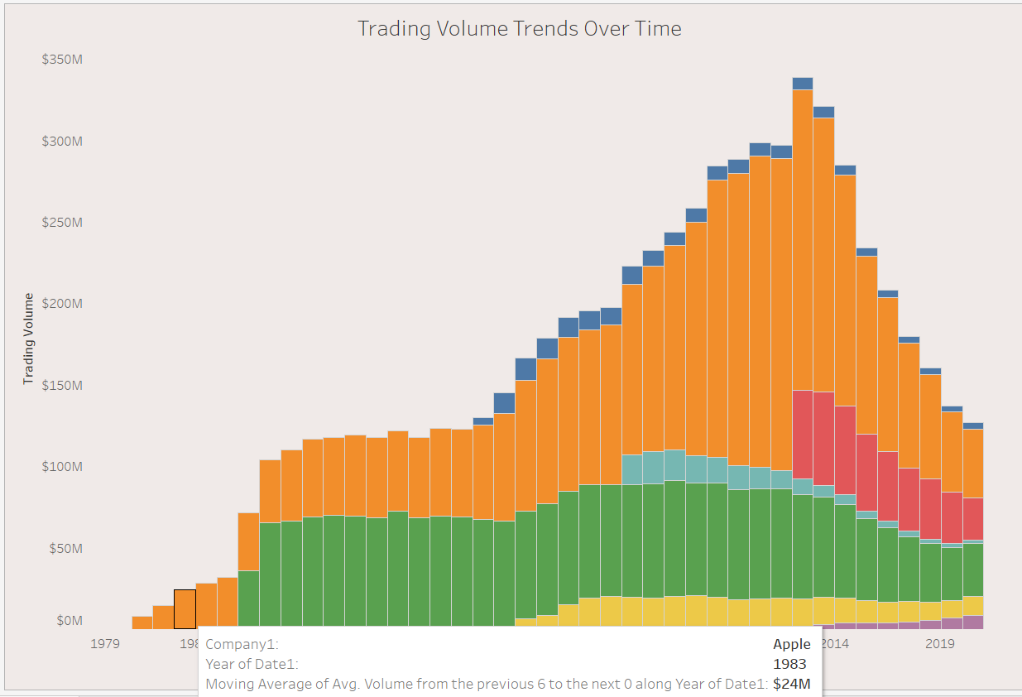

Q3(Story3)

The scatterplot maps **day-over-day percentage changes** in **price** (x-axis) and **volume** (y-axis), enabling users to assess **market sentiment and volatility**.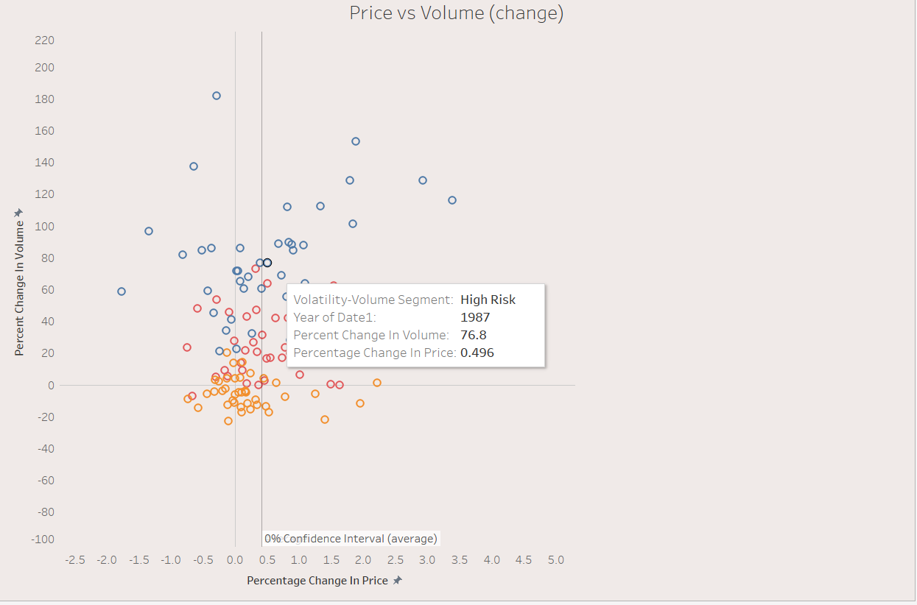

## Q4(Story4)

This technical analysis chart overlays **short-term (MA50)** and **long-term (MA200)** moving averages. Investors rely on crossovers between these two lines to detect **momentum reversals**:

* **Bullish Signal:** MA50 crosses above MA200
* **Bearish Signal:** MA50 drops below MA200

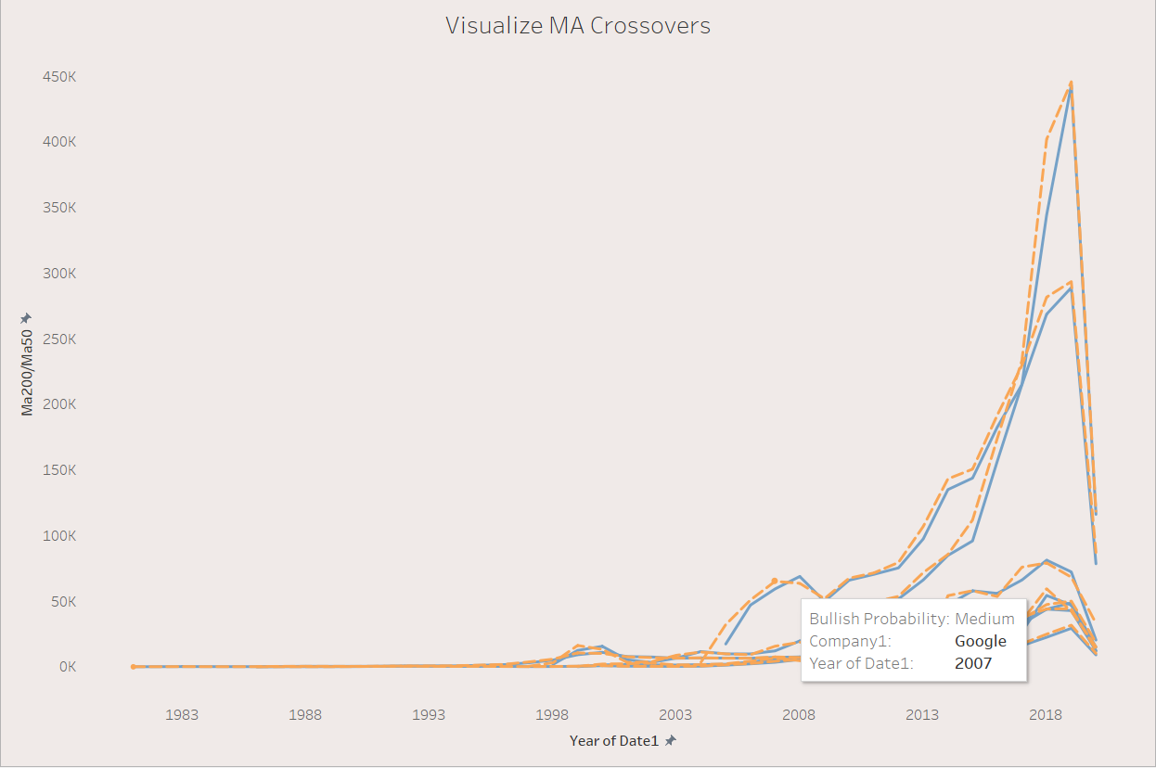

# Discussion

We have sharing this Tableau dashboard for investment analysts and strategic retail traders taking inspiration from User-Centred Design (UCD) principles and Human-Computer Interaction (HCI) principles to enhance interpretability and insight discovery from financial data. It was designed by data-savvy user persona, for whom it's necessary to filter actionables signals from extensive historical stock records.

Grounded in Nielsen’s (1994) heuristic, “visibility of system status”, dynamic tooltips, real-time filtering, and predictive overlays, e.g., moving average forecasts, were utilized to deliver instantaneous system feedback and minimize cognitive burden. Such interactions allow users to rapidly grasp the changes in stock trends and volume behavior without the need to manipulate complicated analytical models by hands.

The visualization was designed using UCD principles (notably including ISO 9241-210:2010). Each view was specially designed for its corresponding question, (e.g., line charts for time-series of closing prices; scatterplots for correlation analysis; and dual-line comparisons for MA crossover detection) to ensure the tight integration among user need, visual encoding and task flow.

Furthermore, Schneiderman’s (1996) Visual information-seeking Mantra (overview first, zoom and filter, then details on demand) was put into practice in all the charts. Users can be filtered by company, switch between forecast views, and hover to see exact values, traversing from macro to micro in no time at all. Such visual techniques proved very helpful to complex price-volume sentiment plots; they turn high-density clusters into something digestible through interactive content.

The psychology of color and simplicity in design layout were taken into account, along with performance optimization, to create a dashboard that is not only analysis-driven, but also visually digestible. The addition of moving average forecasting models further narrows the gap between backward and forward looking analysis which is essential in modern trading systems.

Ultimately, this design couples visual storytelling with the critical judgment of stock traders, encouraging informed decisions, and reducing the overhead of technical analysis.

# Critical comparison between Tableau and Shiny as a visualisation tool

**Q1: Line Graph – Closing Prices Over Time**  
 **Tableau** uses a polished stacked area chart, enabling intuitive visual growth comparison across companies. While forecasts can be activated, they aren't always visible by default.  
 **Shiny (R)** provides a clean multi-line chart with interactive filters for company and date. It captures trends effectively but lacks built-in forecasting, limiting future insight.  
 *Shiny Strengths:* Clear interface, good filters  
 *Weakness:* No forecasting integratin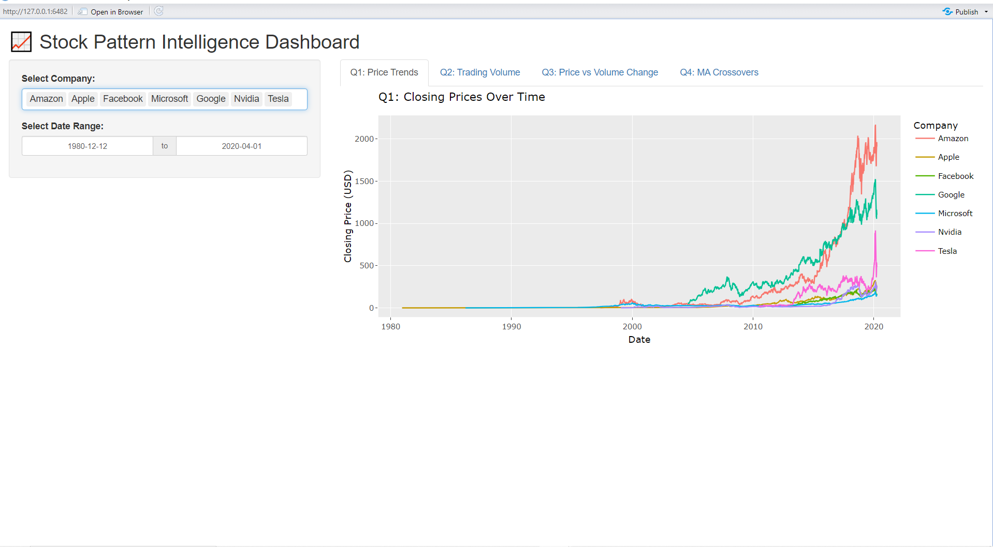

**Q2: Trading Volume Over Time**  
 **Tableau** displays a year-wise stacked bar chart for trading volumes, offering clean, segmented company-wise comparisons.  
 **Shiny (R)** shows raw volume as stacked area plots. While interactive, it lacks per-year aggregation, making interpretation harder due to granular dates and overlapping colors.  
 *Shiny Strengths:* Interactive, intuitive layout  
 *Weakness:* No year-based summary; cluttered x-axis

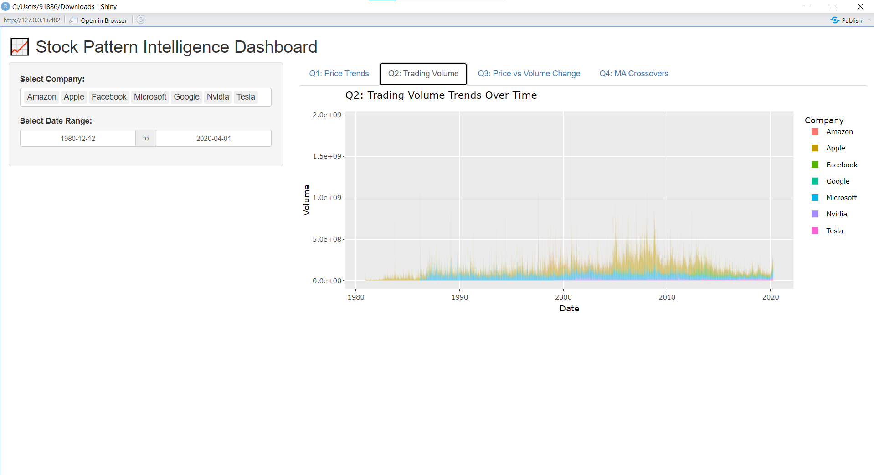

**Q3: Scatter Plot – Price vs Volume Changes**  
 **Tableau** adds more depth via volatility-based color coding and cluster segmentation (e.g., risk zones), aiding interpretation.  
 **Shiny (R)** supports basic scatter plots with % change axes and company-wise colors, but lacks contextual clustering or risk stratification.  
 *Shiny Strengths:* Functional interactivity, clarity  
 *Weakness:* No volatility segmentation, fewer cues for interpretation

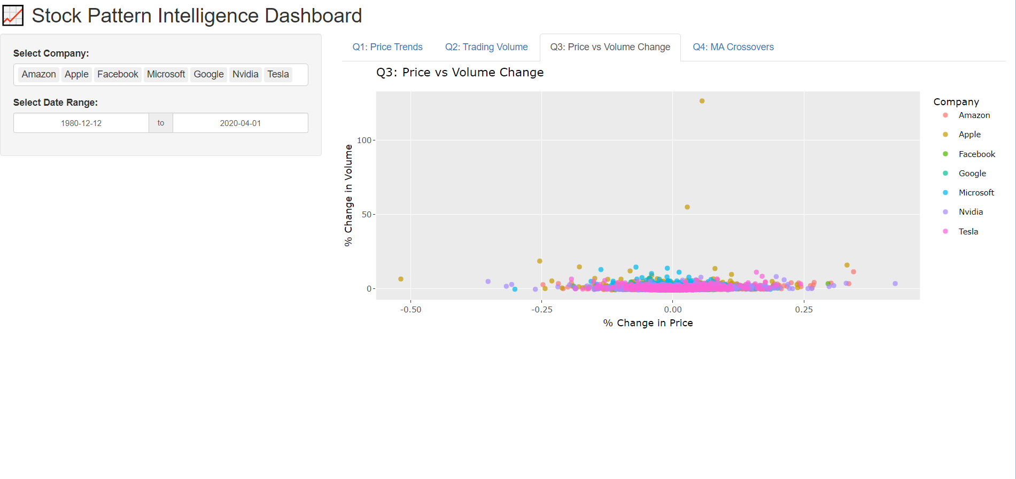

**Q4: MA50 vs MA200 Crossovers**  
 **Tableau** excels with dual-line crossover views and forecasting indicators (bullish/bearish signals), enabling technical insight.  
 **Shiny (R)** facets company-wise plots for clarity but lacks advanced logic for forecasting or crossover events.  
 *Shiny Strengths:* Clean faceted design  
 *Weakness:* No crossover interpretation or forecasting filters

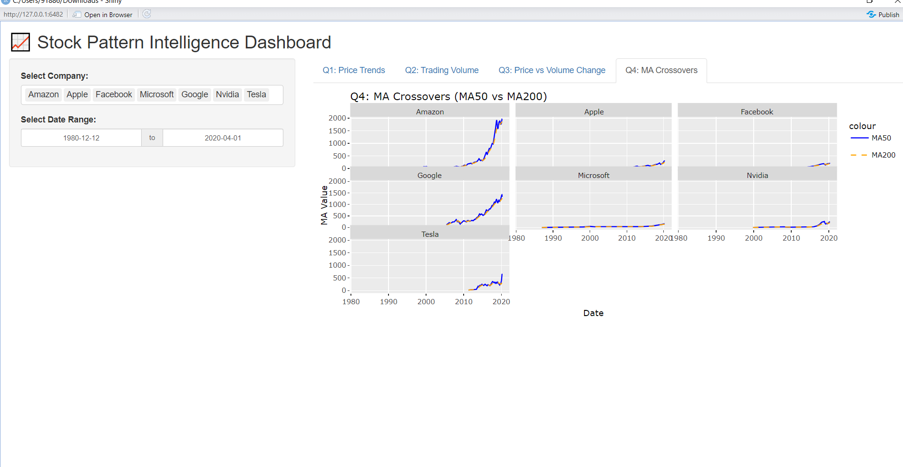

# Conclusion

The aim of the project was to feedback into investor’s decision making by analysing long term stock performance and trading activities of the top big tech companies. With an interactive Shiny dashboard analysis we cover the questions with regards to price trends, trading volume dynamics as a univariate time series, price-volume correlations, and moving average cross-overs.

By means of line charts, scatter plotss, and faceted trend visualizations, the project transformed raw market data into insights. Tableau had sophisticated statistical and visual modelling, but Shiny implementation was flexible, user-driven and highly interactive. In general, the project successfully transformed the historical stock trend into actionable insights, enhancing technical skills and data storytelling abilities along the way.

# **References:**

Data source:- <https://finance.yahoo.com/quote/AAPL/history/>

*Simple Visualization Techniques for Quantitative Analysis:-* <https://www.perceptualedge.com/library.php>